Callum Jago

Alex Payne

**Graphics Project 4 Documentation**

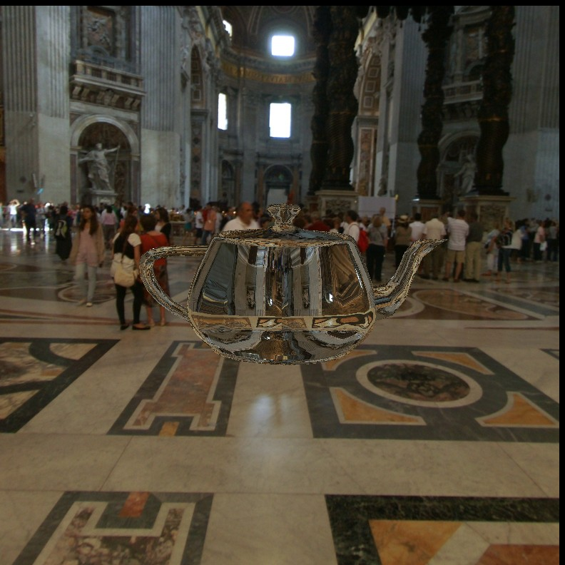

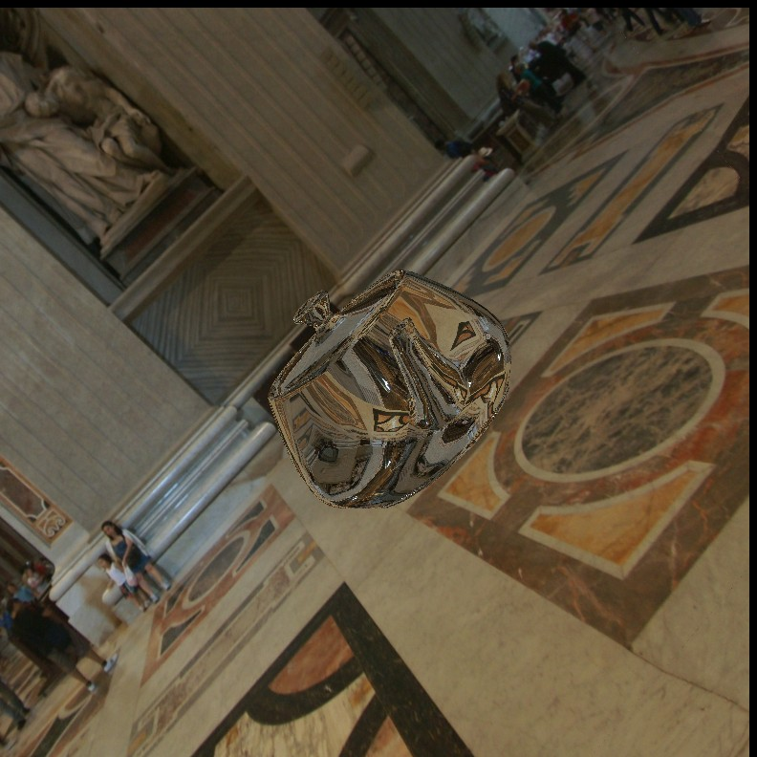

**Implementation:**

While implementing the cube map used for reflection, I encountered problems with several gl commands resulting in errors. Theses errors prevented me from being able to construct the VAO needed for the cube map. Instead I used a single image for reflection. While this isn’t a correct solution, it does provide a fairly decent effect as long as you don’t look too closely. Reflection was implemented by reflecting the eye direction vector across the surface normal in the vertex shader and then using this vector as the texture coordinates in the fragment shader.